NATALIE D-NAPOLEON

YOU WANTED TO BE THE SHORE BUT INSTEAD YOU WERE THE SEA

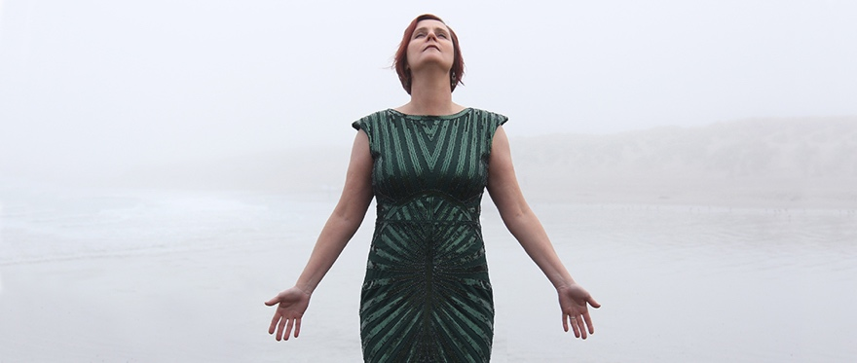

Natalie D-Napoleon is an Australian/American singer-songwriter and award-winning poet who shares her time between Fremantle, Western Australian and Santa Barbara, California. In the same vein as the likes of Patti Smith, Willy Vlautin, and Leonard Cohen, Natalie has successfully explored both writing and songwriting across her 25-year career.

Natalie commenced her musical career in 1996 fronting Perth indie-rock band Bloom - which won the 1997 WAMI for Most Promising New Act – all the while publishing poetry in journals such as Westerly and undertaking live readings. In 1999 Natalie helped break new ground for Americana music in Australia by forming the alternative-country ensemble Flavour of the Month, which released its debut recording, Fear of Falling (Treadmill Records), in 2000.

In 2005 Natalie branched out as a solo artist, releasing her debut solo recording, After the Flood (MGM). After relocating to California in 2008 and forming a trio with Kenny Edwards (Stone Poneys/Linda Ronstadt) and Dan Phillips (Peter Gabriel), the following year the group recorded a covers EP titled Here in California. Their acoustic cover of AC/DC's "You Shook Me All Night Long” made playlist rotation around Australia and was featured on ABC Music's Under the Covers.

In 2012 the trio teamed up with producer David Piltch (kd lang/Joe Henry) to record the album, Leaving Me Dry. With Piltch on bass, Edwards on guitar, and Phillips on piano, the quartet was joined by Victoria Williams on banjo, Greg Leisz (Wilco/Joni Mitchell/Jackson Browne) on pedal steel, Phil Parlapiano (Grant Lee-Buffalo/Joan Baez) on accordion and Aaron Sterling (John Mayer/Taylor Swift) on drums.

In 2013 Natalie returned to creative writing. In 2018 she was awarded the Bruce Dawe National Poetry Prize for her poem “First Blood: A Sestina.” The following year Natalie headlined the Perth Poetry Festival which was followed by Ginninderra Press releasing her debut poetry book First Blood. Her poetry has subsequently been published in Australian Poetry Journal, Meanjin, The Australian, and Writer’s Digest (US) to name a few.

In 2019 Natalie recorded her fourth solo album with one microphone in a one-hundred-year-old chapel nestled in the hills behind Santa Barbara.

You Wanted to Be the Shore But Instead You Were the Sea features James Connolly (Van Dyke Parks/Jeff Bridges) on bass, Doug Pettibone (Lucinda Williams/John Mayer) on guitar, pedal steel, and mandolin, and Dan Phillips on piano and percussion. The album continues Natalie’s impassioned journey through music and words, pushing the boundaries of women’s voices in traditional song.

For more information, images and music, or to arrange and an interview with Natalie, please contact Stuart Coupe - coupe@laughingoutlaw.com.au

